VOTE FOR VILLAGE OF LANSING PARK NAMES
Please select (with checkmark or X), or write in, ONE name for each of the park locations, below.
See reverse side for brief biographies of park-name nominees.
Dart-Parcel Park (Northwoods Drive)  - Rita and Sy Smidt Park  - Valerie Gyrisco Park  - Marian Hartill Park  Other: _________________________________________________________  _________________________________________________________ | 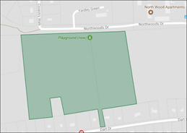
Uptown Road Park (across from Dankert Park)  - Global Village Park  - Valerie Gyrisco Park  - Ned Hickey Park  - Rita and Sy Smidt Park  Other: _________________________________________________________  _________________________________________________________ | 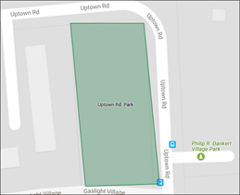
Pocket Park (Craft Rd. and Leif's Way)  - Ned Hickey Park  - Valerie Gyrisco Park  - Rita and Sy Smidt Park  Other: _________________________________________________________  _________________________________________________________ | 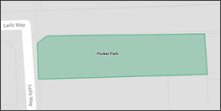
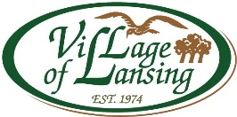

NOMINEE BIOGRAPHIES

Valerie Gyrisco
Valerie (Val) Gyrisco was born and grew up in Montreal, Canada with summers in the nearby Laurentian Mountains. She graduated from McDonald College of McGill University. During World War II she served as a dietitian and officer in the Canadian Army in Great Britain and in the Italian Campaign. After the war, she received a master's degree in nutrition from Cornell University, taught food chemistry at the Cornell Hotel School, and later served as the dietitian at McGraw House in Ithaca. Val was active in Village of Lansing government, the Ithaca Dog Training Club, and the Adirondack Mountain Club. She was an avid hiker, canoeist, and gardener with a great love of the outdoors. An enthusiastic skier, she continued down-hill skiing until age 89. In later years, she traveled the world to visit the Soviet Union, China, the Alps, Nepal, Turkey, Egypt, Iceland, Machu Pichu, and the Galapagos. Val was a Planning Board member from 1979 to 1980; from 1984 to 1989, and in 1992 served as an alternate. Val also served a year as a Trustee before joining the Planning Board.

Marian Hartill
Marian Hartill represented the very best qualities of the residents of the Village of Lansing. She was the treasurer of the Community Party from 2008 until her illness in December made it impossible for her to continue. As a faithful observer for the Community Party for Village meetings especially the Planning Board she provided valuable insight to the Village residents on the matters before the Boards. Her help with canvasing and getting out the vote in Village elections added to the vitality of the Village and she was the gracious hostess for the annual Mayor’s Holiday Party. Marian passed away on February 25th and will be greatly missed.

Ned Hickey
As one of the "founding fathers" of the Village, Ned Hickey was elected to be on the first Board of Trustees. When the Planning Board was formed, he was assigned as the first board chairperson. Ned put in 25 years on the Village boards. He was instrumental in guiding projects such as the construction of Pyramid Mall, redesign of Triphammer Road, and development of the Cornell Business Park at the airport. When he retired in 2010, Ned won the NYS award for outstanding Planning Board Chairman.

Rita and Sy Smidt
Rita Smidt organized the Lansing Village Study Group, which brought about incorporation of the Village of Lansing in 1974. She also served as campaign chair of the Community Party, through the administrations of the first two mayors, and remained active in Village affairs until her last illness in 2000. As Mayor Hartill wrote in the October 2000 Village Newsletter, “Rita probably more than anyone was responsible for the formation of the Village.” To learn more about our Village, read Rita’s excellent book, Lansing at the Crossroads.
Seymour (Sy) Smidt, Rita’s husband, held a PhD from the University of Chicago, and was a Professor of Economics and Finance at Cornell's business school. He served from 1975 until 1981 as the first Mayor of the Village of Lansing.

Global Village Park
This park-name nominee originated from an “Art in the Park” project guided by Trustee Gerry Monaghan to recognize the fact that Village residents represent more than 20 countries from around the globe. School-age children created grapevine-braiding-style words in their native languages for display in the Village park across from Dankert park.

